**REACT**

**#5**

My Academy team at Cognizant want to create a dashboard containing the details of ongoing and completed cohorts. A react application is created which displays the detail of the cohorts using react component. You are assigned the task of styling these react components.

Downloaded and build the attached react application.

1. Unzipped the react application in a folder
2. Opened command prompt and switched to the react application folder
3. Restored the node packages.
4. Opened the application using VS Code

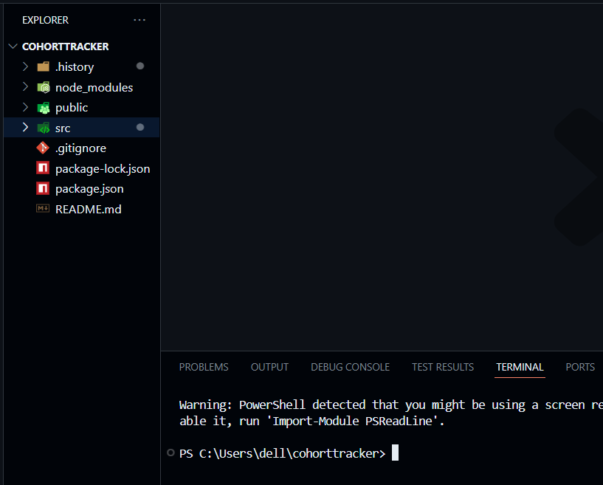

1. Created a new CSS Module in a file called “CohortDetails.module.css”
2. DefineD a css class with the name as “box” with following properties

*Width = 300px;*

*Display = inline block;*

*Overall 10px margin*

*Top and bottom padding as 10px*

*Left and right padding as 20px*

*1 px border in black color*

*A border radius of 10px*

1. Defined a css style for html <dt> element using tag selector. Set the font weight to 500.

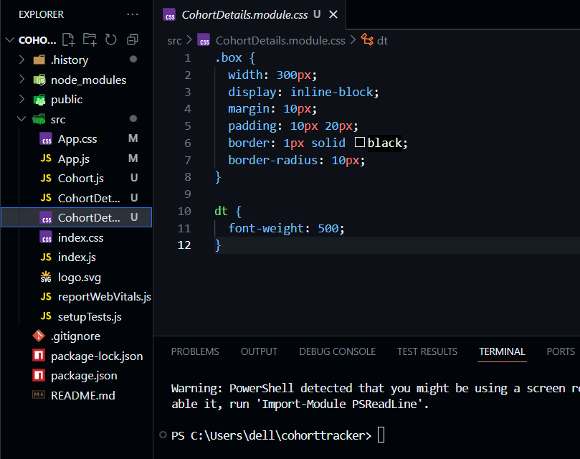

1. Opened the cohort details component and import the CSS Module
2. Applied the box class to the container div
3. Defined the style for <h3> element to use “green” color font when cohort status is “ongoing” and “blue” color in all other scenarios.

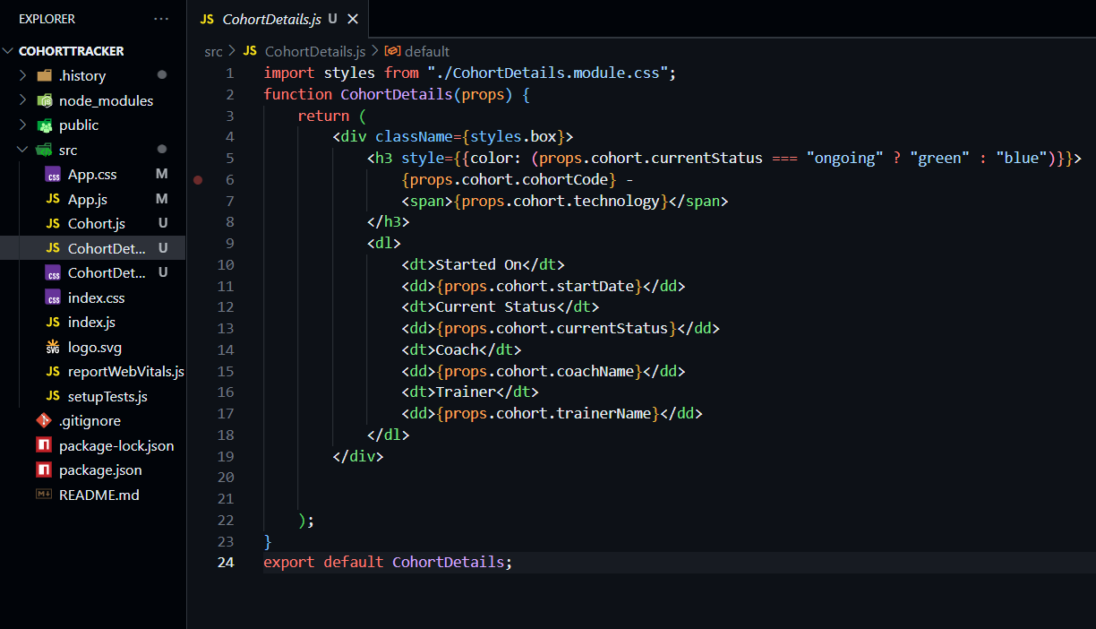

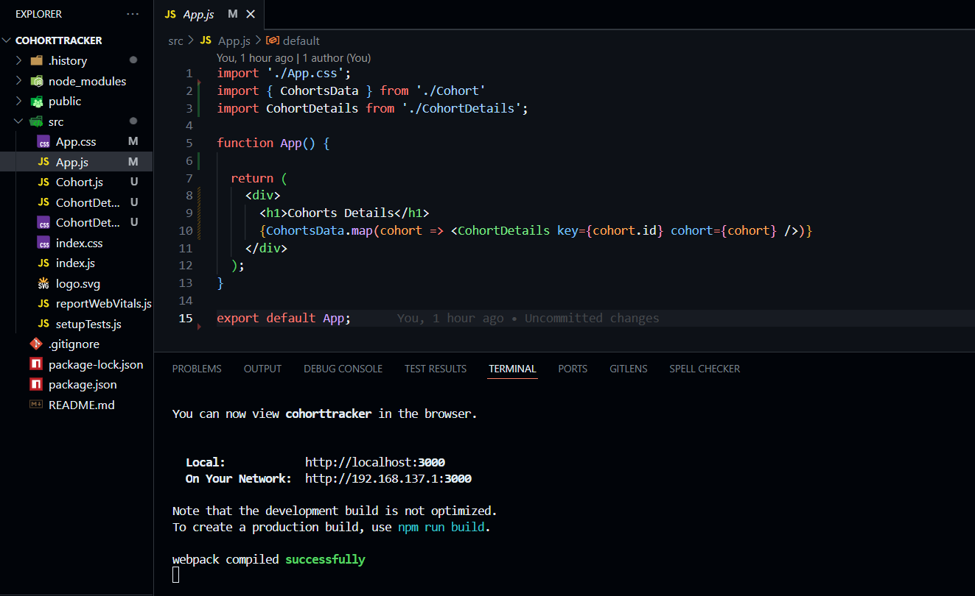

**OUTPUT-**

